Congo Mines Data Structure
ETL from PostgreSQL to MySQL WP database structure

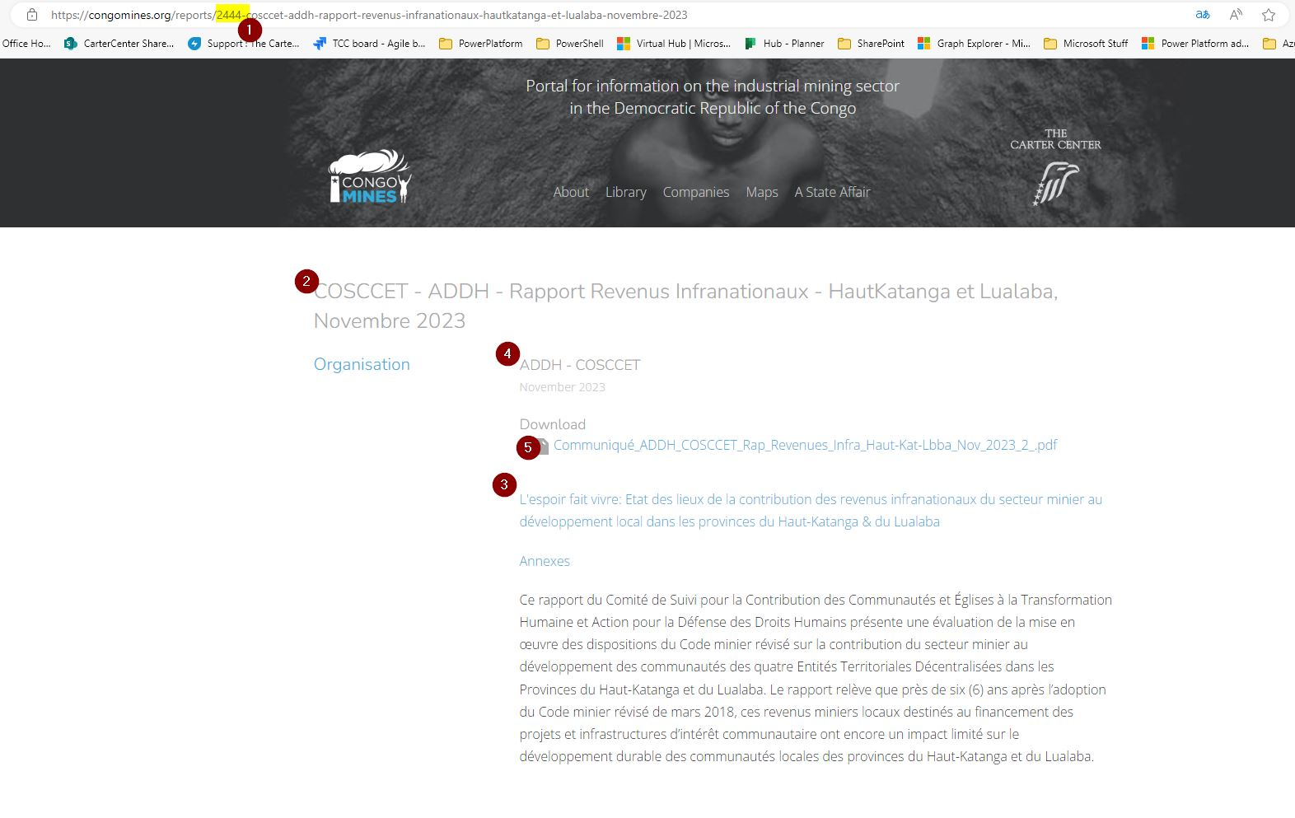

- The URL displays the Report ID
  - Report ID is found in the REPORTS table (SELECT * from Reports where ID=2444;)
- Title field from the Reports table
- Summary field from the Reports table
- Source_ID field from the Reports table relates to the Sources table (SELECT * from Sources where ID=591;). The name field is used to display here
- The field, attachable_id is used to relate the report to this attachment. Use the Report ID to query for the attachment in the Attachments table (SELECT * from Attachments where attachable_id = 2444;)

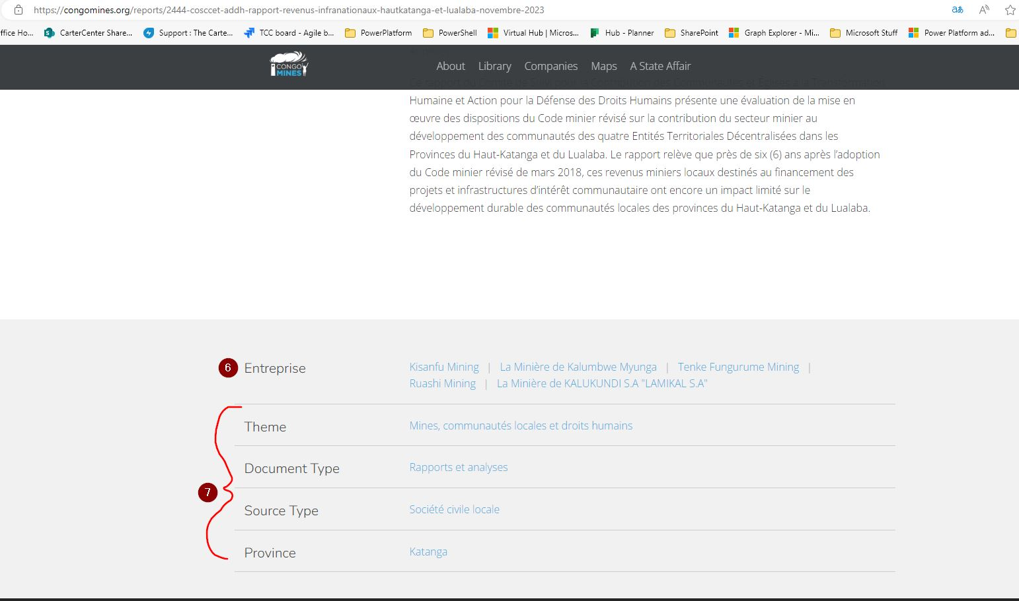
- Use the Report ID to query for the Enterprise information (drc_company) in the Report_Relations table (SELECT * from Report_Relations where report_id=2444;)
  - Based on the query, look up the companies associated with the drc_company_id field in the DRC_Companies table
- Use the Report ID to query the Report_Categories table (SELECT * from Report_Categories where report_id=2444;)
  - Based on the query, look up the categories associated with the category_id field in the Categories table

To recreate this page, a view in Formidable Forms was created from the Reports Form (form #17).
For existing reports, the PostgreSQL ID number has to be included to ensure a match to recreate what is in the current site.
Issues:
- Enterprise information not displaying
- The remaining categories do not display based on parent category. The field would need to be deserialized to show it
- The parent id’s for the categories selected

The numbers in the square boxes relate to the fields in the wp_frm_items_metas table in the WordPress database:
This example is related to item 1280, which can be found in the wp_frm_items table in the WordPress database:

Below is the serialized array field 183 of the Reports form which is the attachment related to this report. The post can be queried in the wp_posts table in the WordPress database using the ID from the array in this field (531). Using the ID to query the wp_postmeta table in the WordPress database will display information about the attachment.
In the PostgreSQL database, the following tables are used to store information about the attachments: Reports and Attachments
Reports table:
The ID field in the report table will match the attachable_id field in the Attachments table.
Example: Report 2444 used in this document.

Attachments table:
The attachments for reports are in a file system three or more levels deep. (i.e. 000/002/379).
This folder structure is represented by the ID field in the Attachments table in PostgreSQL: 2379 -> 000/002/379

WordPress Database schema resources
- WordPress Database: A Detailed Guide with Best Practices (jetpack.com)
- Database Description « WordPress Codex
- Using Alternative Databases « WordPress Codex

WordPress Solutions
- WordPress Erase and Export Personal Form Data - Formidable Forms
  - Where is my data stored? - Formidable Forms

