Congo Mines Data Structure

ETL from PostgreSQL to MySQL WP database structure

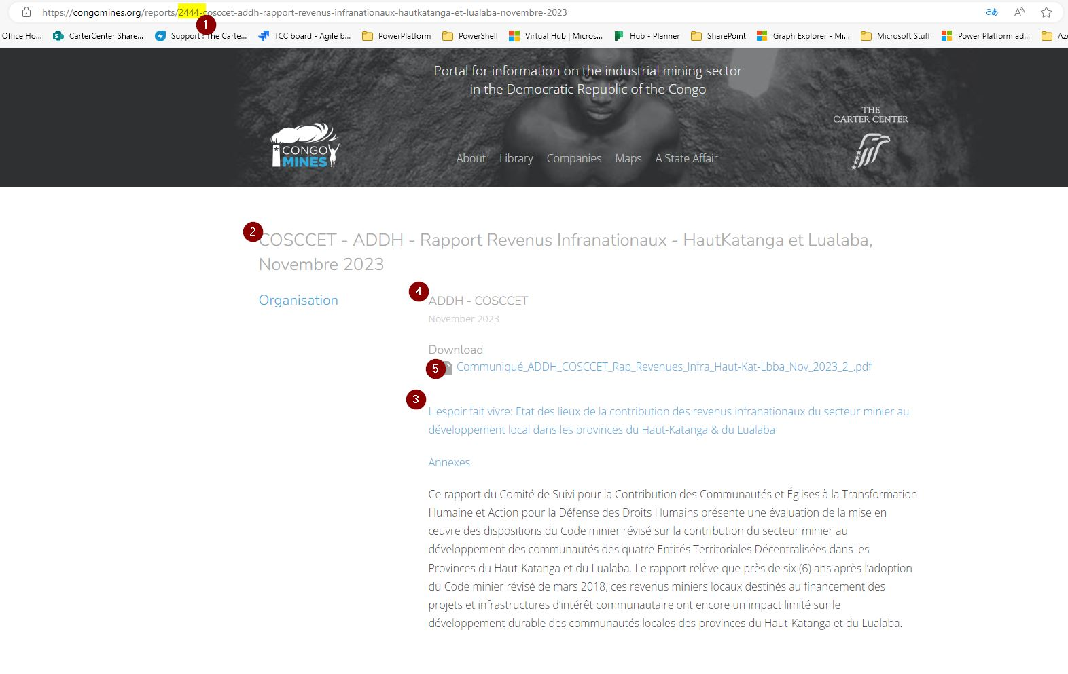

1. The URL displays the **Report ID**
   1. **Report ID** is found in the ***REPORTS*** table (SELECT * from Reports where ID=2444;)
2. Title field from the ***Reports*** table
3. Summary field from the ***Reports*** table
4. Source_ID field from the ***Reports*** table relates to the ***Sources*** table (SELECT * from Sources where ID=591;). The name field is used to display here
5. The field, attachable_id is used to relate the report to this attachment. Use the **Report ID** to query for the attachment in the ***Attachments*** table (SELECT * from Attachments where attachable_id = 2444;)

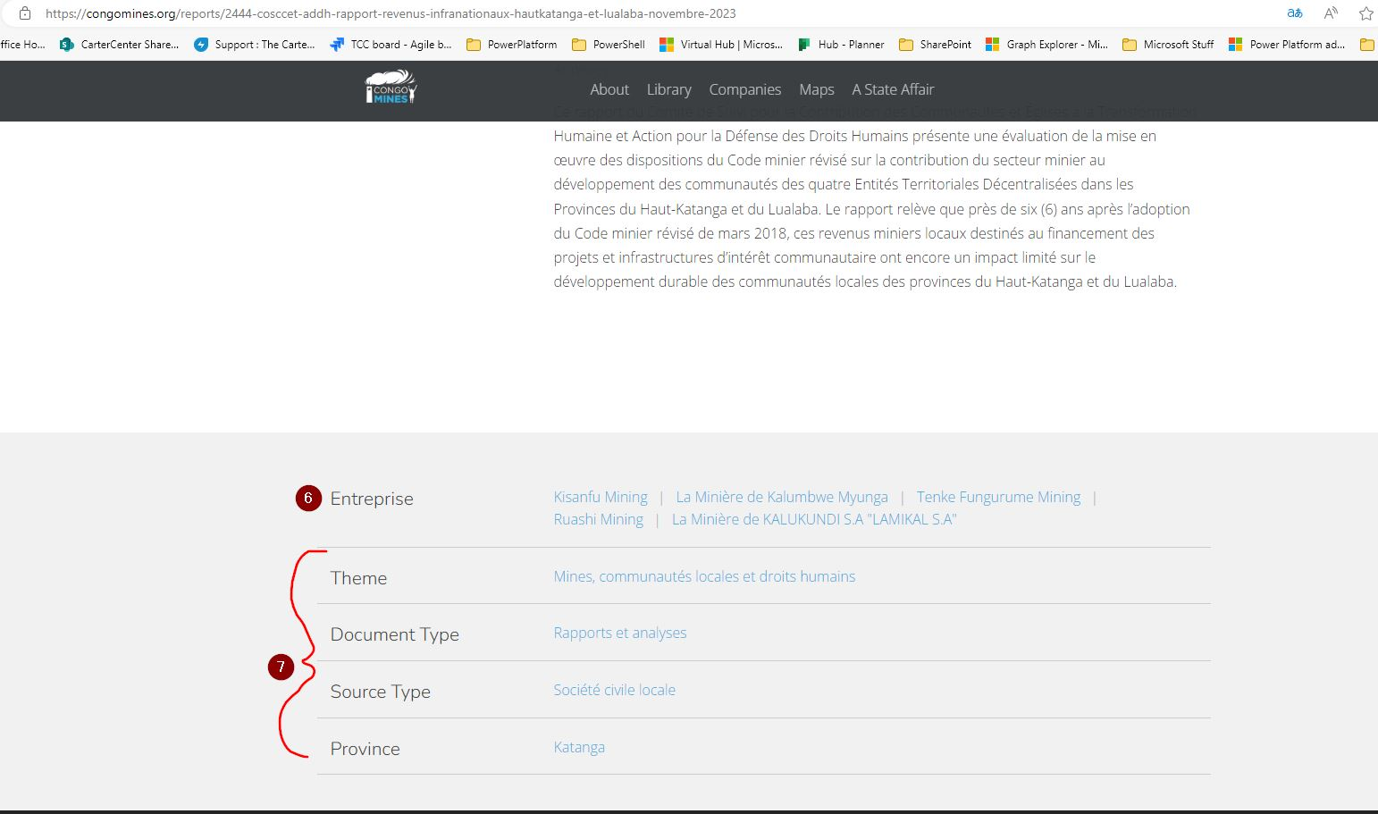

1. Use the **Report ID** to query for the Enterprise information (drc_company) in the ***Report_Relations*** table (SELECT * from Report_Relations where report_id=2444;)
   1. Based on the query, look up the companies associated with the drc_company_id field in the ***DRC_Companies*** table
2. Use the **Report ID** to query the ***Report_Categories*** table (SELECT * from Report_Categories where report_id=2444;)
   1. Based on the query, look up the categories associated with the category_id field in the ***Categories*** table

To recreate this page, a view in Formidable Forms was created from the Reports Form (form #17).

For existing reports, the PostgreSQL ID number has to be included to ensure a match to recreate what is in the current site.

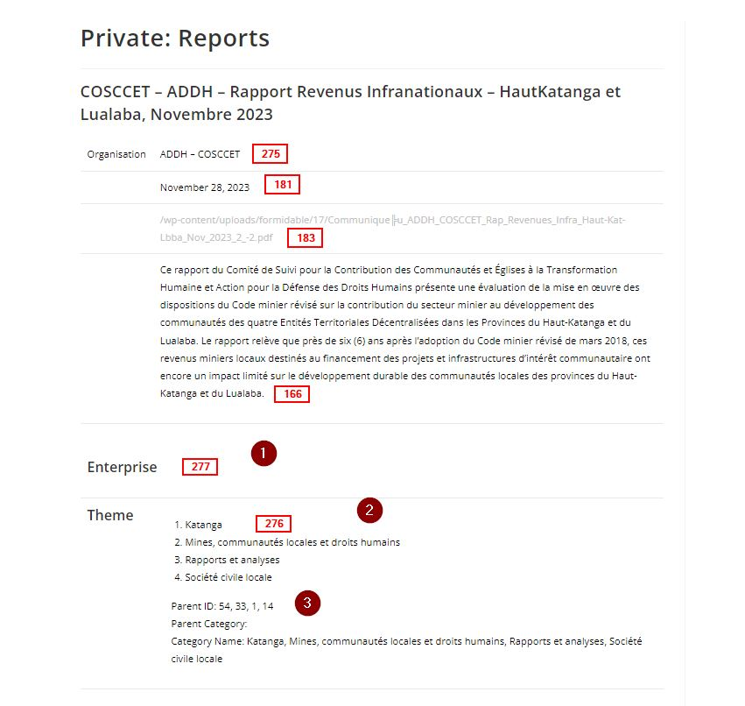

Issues:

1. Enterprise information not displaying
2. The remaining categories do not display based on parent category. The field would need to be deserialized to show it
3. The parent id’s for the categories selected

The numbers in the square boxes relate to the fields in the wp_frm_items_metas table in the WordPress database:  
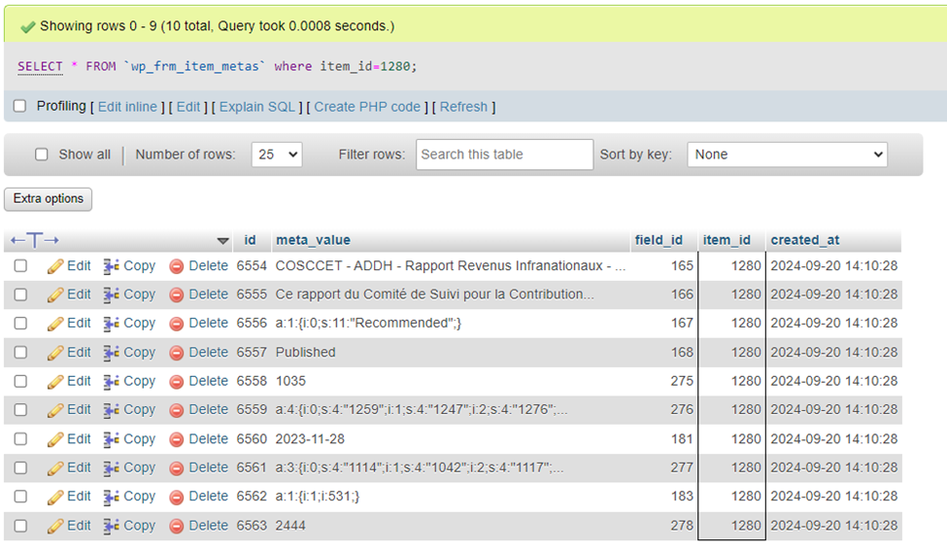

This example is related to item 1280, which can be found in the wp_frm_items table in the WordPress database: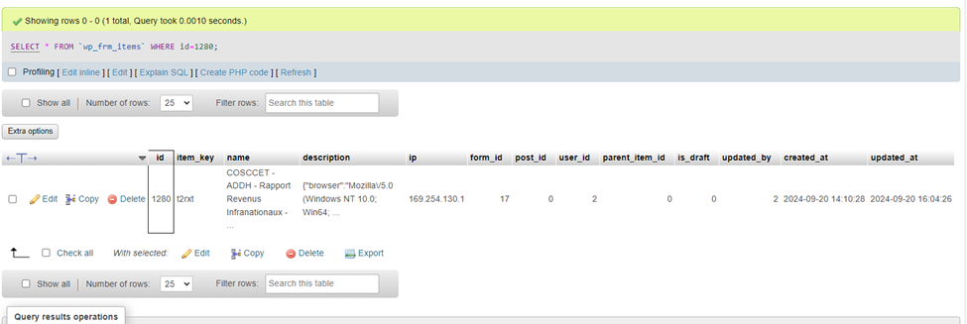

Below is the serialized array field 183 of the Reports form which is the attachment related to this report. The post can be queried in the wp_posts table in the WordPress database using the ID from the array in this field (531). Using the ID to query the wp_postmeta table in the WordPress database will display information about the attachment.

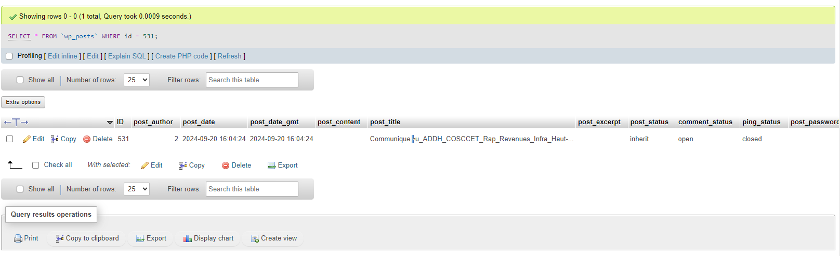

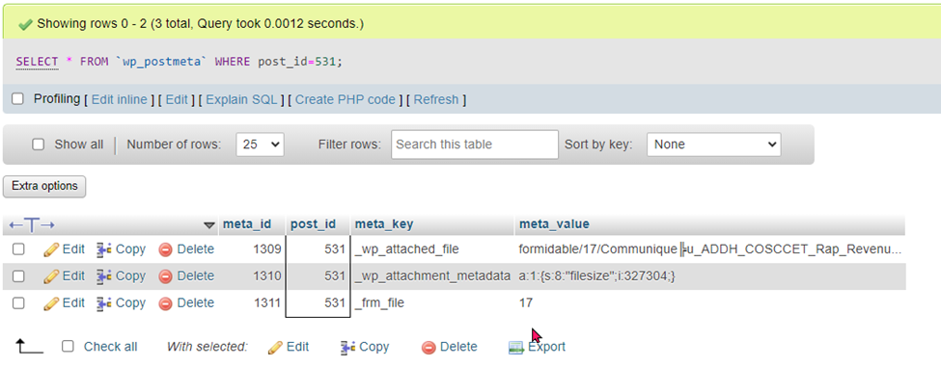

In the PostgreSQL database, the following tables are used to store information about the attachments: Reports and Attachments

**Reports table:**

The ***ID*** field in the report table will match the ***attachable_id*** field in the Attachments table.

Example: Report **2444** used in this document.

**Attachments table:**

The attachments for reports are in a file system three or more levels deep. (i.e. 000/002/379).

This folder structure is represented by the ***ID*** field in the Attachments table in PostgreSQL: **2379** -> 000/00**2/379**

# WordPress Database schema resources

* [WordPress Database: A Detailed Guide with Best Practices (jetpack.com)](https://jetpack.com/blog/wordpress-database/#:~:text=The%20WordPress%20database%20is%20organized%20into%20tables%20that,for%20posts%2C%20one%20for%20comments%2C%20and%20so%20on.)
* [Database Description « WordPress Codex](https://codex.wordpress.org/Database_Description)
* [Using Alternative Databases « WordPress Codex](https://codex.wordpress.org/Using_Alternative_Databases)

# WordPress Solutions

* [WordPress Erase and Export Personal Form Data - Formidable Forms](https://formidableforms.com/knowledgebase/erase-export-personal-form-data/)
  + [Where is my data stored? - Formidable Forms](https://formidableforms.com/knowledgebase/where-is-my-data-stored/)